📢 Scholarship Announcement Statement

Introducing The George “Duck” White Legacy of A-One Scholarship

A-One Support & Mentorship is honored to announce the establishment of the George “Duck” White Legacy of A-One Scholarship, created in loving memory of the late George White — a proud business owner, master craftsman, and dedicated member of the Masonic Fraternity.

Mr. White spent his life building—not just homes and structures through his successful construction company, but also building people, opportunities, and communities. His unwavering dedication to hard work, integrity, and brotherhood continues to inspire us all.
This scholarship is designed to carry forward his legacy by supporting students who share his spirit of service, leadership, and perseverance.

Scholarship Focus:
- Supporting youth pursuing college, trade school, or vocational training, prioritizing those with educational focus in construction, engineering, architecture, business administration or skilled trades.
- Recognizing students who demonstrate leadership, integrity, and a commitment to community service.
- Investing in next generation of leaders who carry forward George “Duck” White’s spirit of excellence, generosity, and determination.

Through this scholarship, we will honor his memory and invest in the kind of future he believed in: one built on hard work, service, and hope.

✨ Scholarship Highlights:
- Open to current high school seniors, mentees connected with A-One Support & Mentorship or the surrounding community of Chester, Kershaw, Lancaster, Lexington, and Richland, South Carolina entering 2- or 4-year college, trade/technical school, or vocational program.
- Awarded annually to a student who demonstrates resilience, leadership, and commitment to service.
- Funds can be applied toward tuition, books, or supplies.

We invite family, friends, and community partners to support this scholarship fund. Together, we can ensure that Mr. White’s spirit of service and mentorship lives on in the next generation of leaders.

📌 To Donate: Visit www.topnotchmentality.com/donate and select George White Legacy of Building Scholarship in the giving options.

George Douglas White Jr. Legacy of A-One Scholarship
Honoring a Life of Faith, Craftsmanship, and Community

The George Douglas White Jr. Legacy of A-One Scholarship was established to honor the life, values, and lasting impact of George “Duck” White—a devoted family man, skilled craftsman, entrepreneur, and servant leader. Known for his integrity, generosity, and dedication to both his community and church, George lived by the principle that true success is measured not only by one’s talents but by the willingness to uplift others.
This scholarship seeks to carry forward his legacy by supporting graduating high school seniors who demonstrate perseverance, leadership, and a commitment to service. By investing in students who embody the same spirit of hard work and integrity that defined George’s life, the scholarship aims to empower the next generation to pursue their goals, build meaningful futures, and continue making a positive impact in their communities.
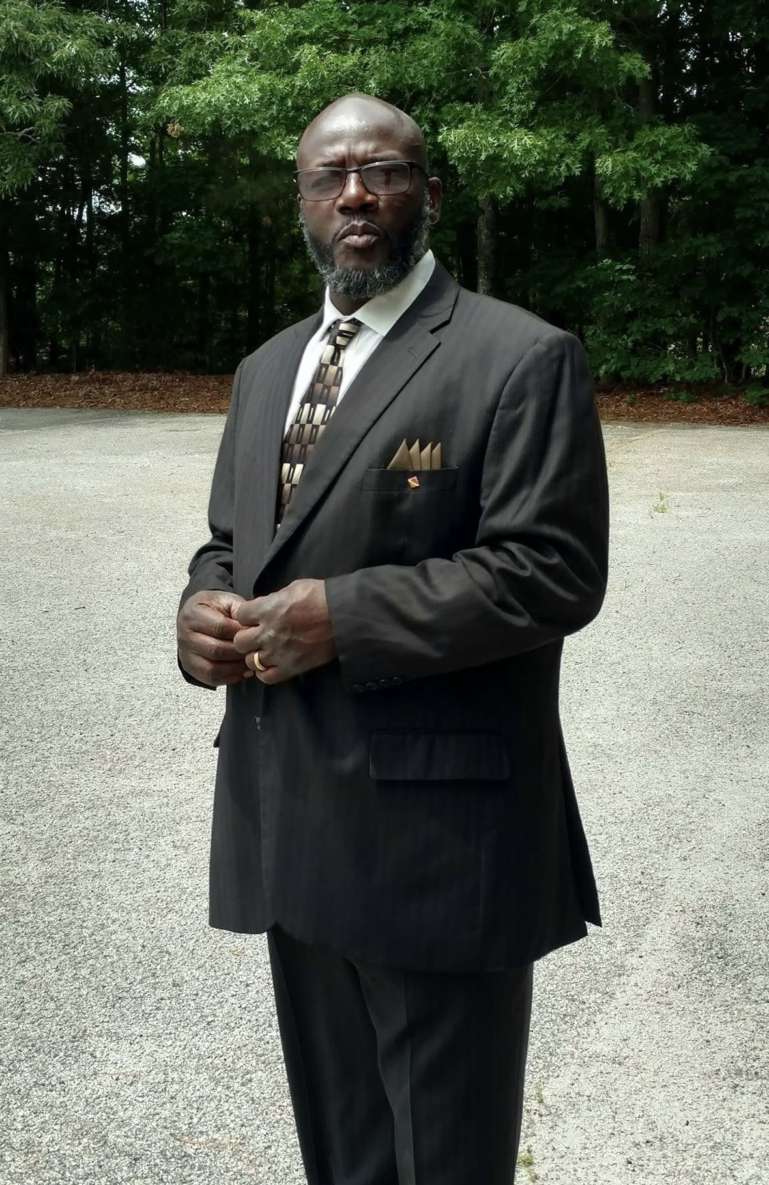
George Douglas White Jr. “Duck”
A Legacy of Faith, Craftsmanship, and Community

Biography
George D. White Jr., affectionately known as “Duck,” was educated in the Lancaster County School District and proudly graduated from Lancaster High School, Class of 1980. From a young age, George carried himself with honesty, humor, and a natural talent that shaped every part of his life.
A gifted carpenter by trade, George transformed raw materials into works of craftsmanship that stood as a testament to his skill, creativity, and attention to detail. His reputation for excellence became so well known that he coined the phrase, “If you want it done right, call WHITE,” a saying that still echoes in the community as a reminder of his workmanship and reliability. Beyond building structures, George built trust and relationships, leaving behind a legacy rooted in integrity and pride in a job well done.
George’s talents reached far beyond carpentry. He was a grill master whose food brought family and friends together, a true fisherman who found peace and joy on the water, and a man of vision who saw possibilities where others saw obstacles. His laughter, wisdom, and straightforward nature made him both a friend and a mentor to many.
Deeply devoted to his faith, George was a faithful member of David Stand AME Zion Church, where he served with honor as Chairman of the Trustee Board. His leadership extended beyond the church walls, as he also served proudly with the Masonic Lodge, Lincoln Lodge #162. In every role, George gave of himself fully—uplifting others, offering guidance, and modeling what it meant to live with purpose.
While George’s professional and community contributions were remarkable, it was his love for family that defined him most. He cherished time spent with loved ones, celebrated their achievements, and stood as a pillar of strength in times of need. His joy for life was seen in simple pleasures—fishing trips, backyard cookouts, cheering for his beloved Oakland Raiders—and in the way he brought people together.
George White will forever be remembered as a man of character, service, and love. His craftsmanship shaped homes, his faith anchored his steps, and his spirit touched countless lives. Though he is no longer with us, his values, his humor, and his unwavering dedication to others continue to inspire and guide those who were blessed to know him.
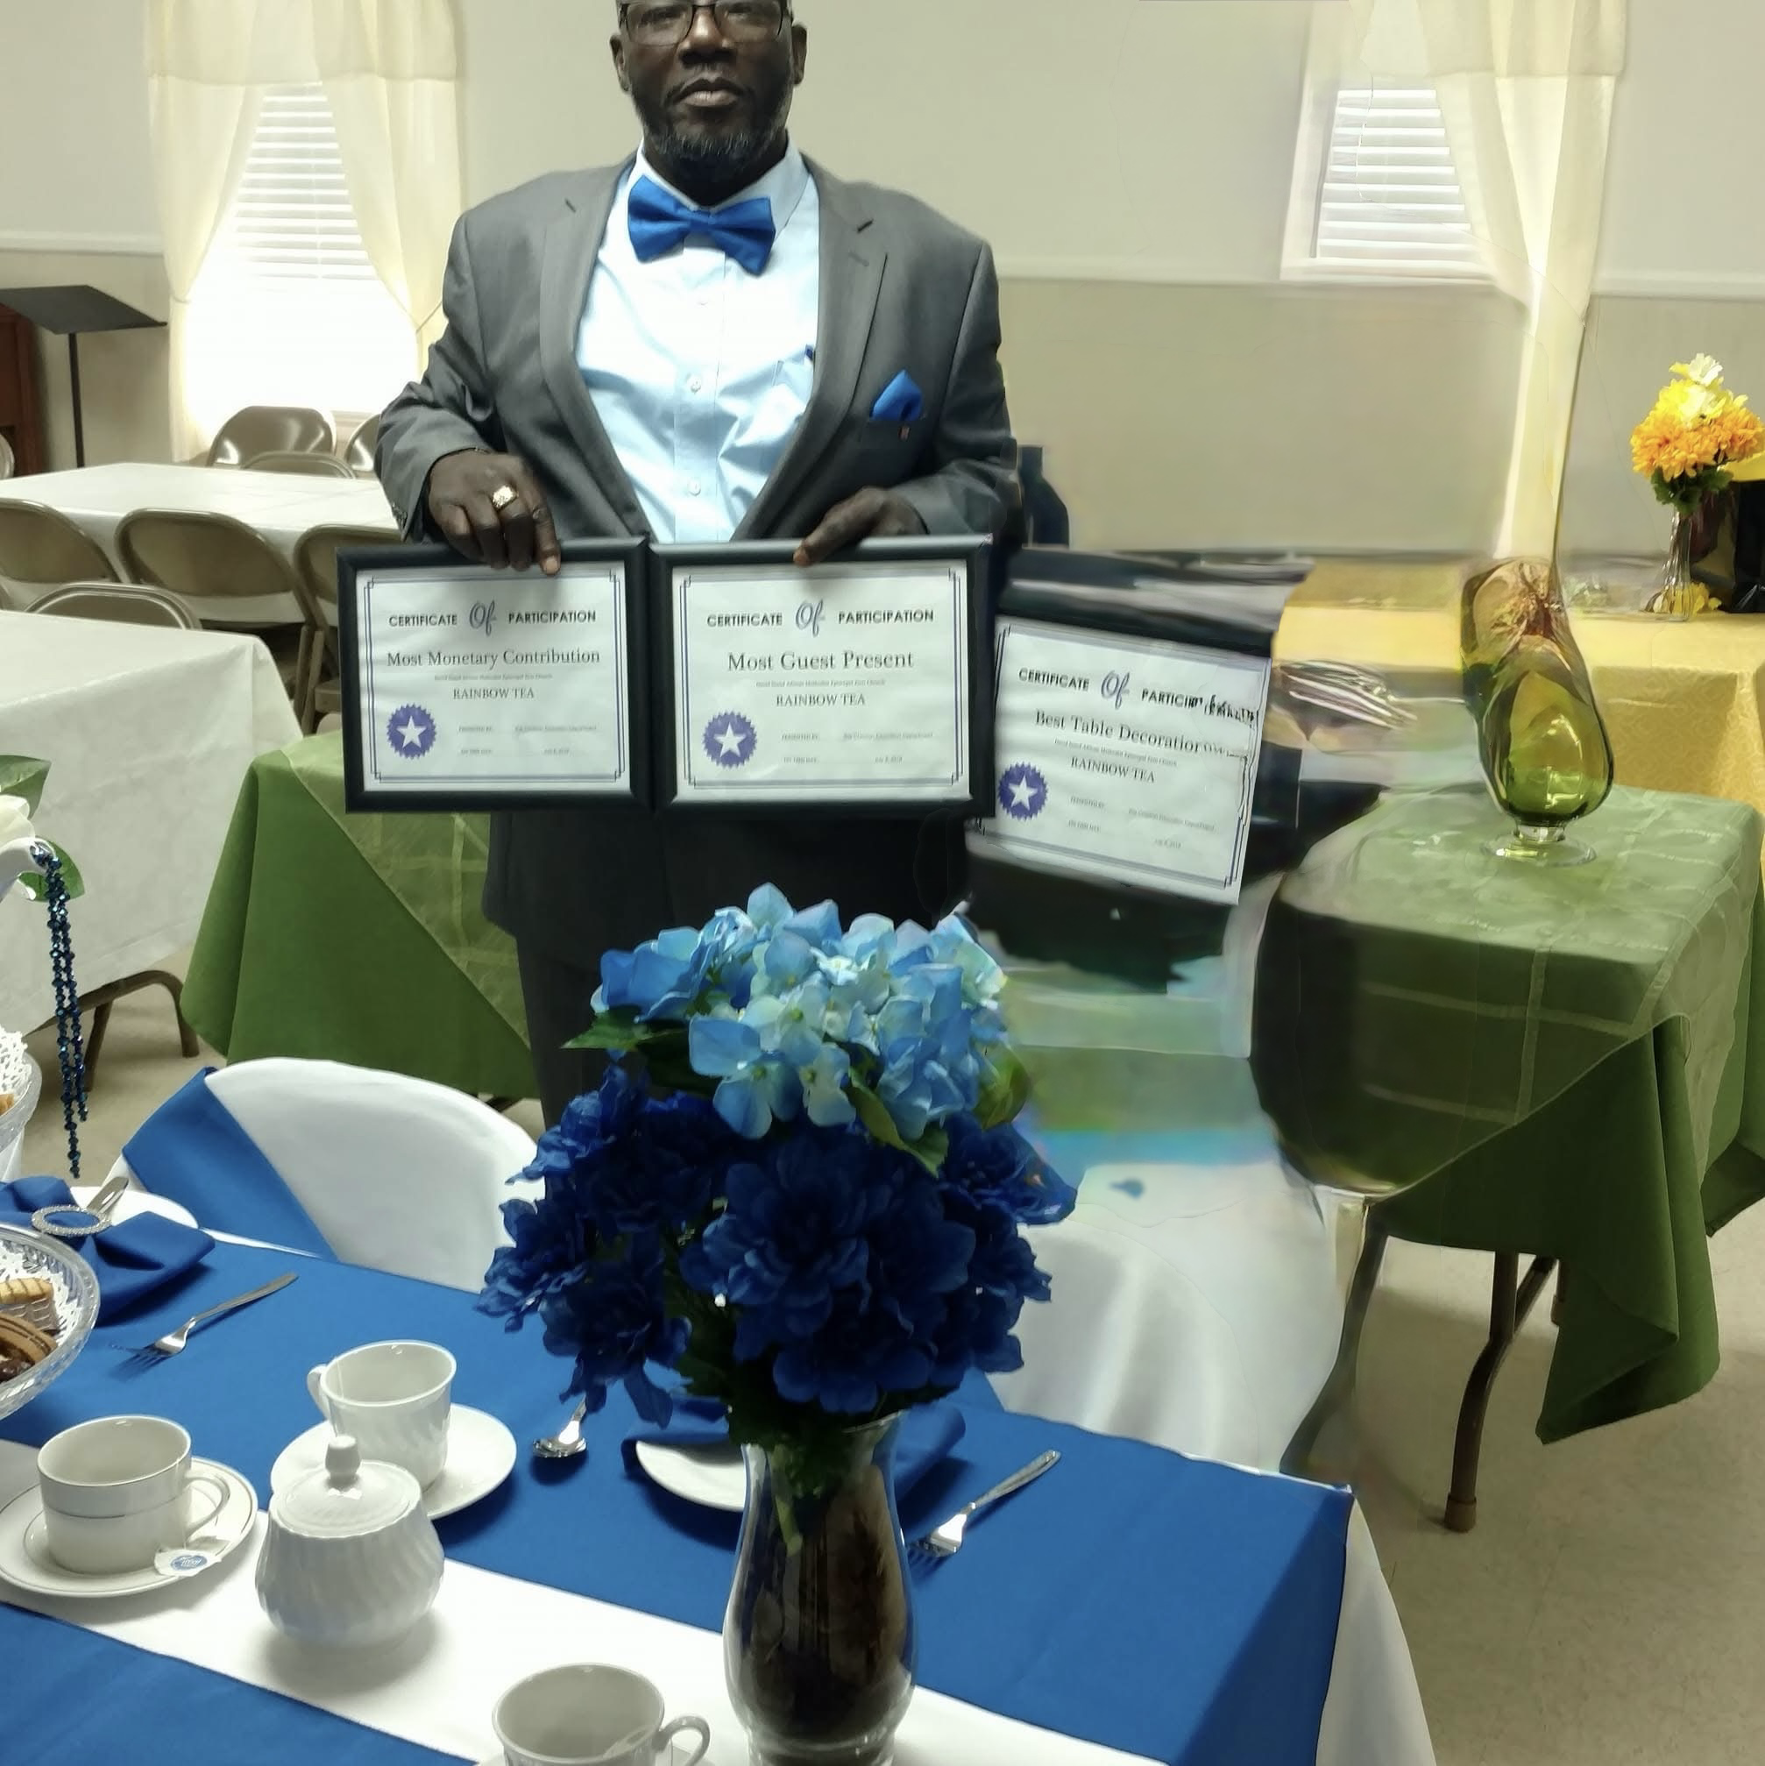
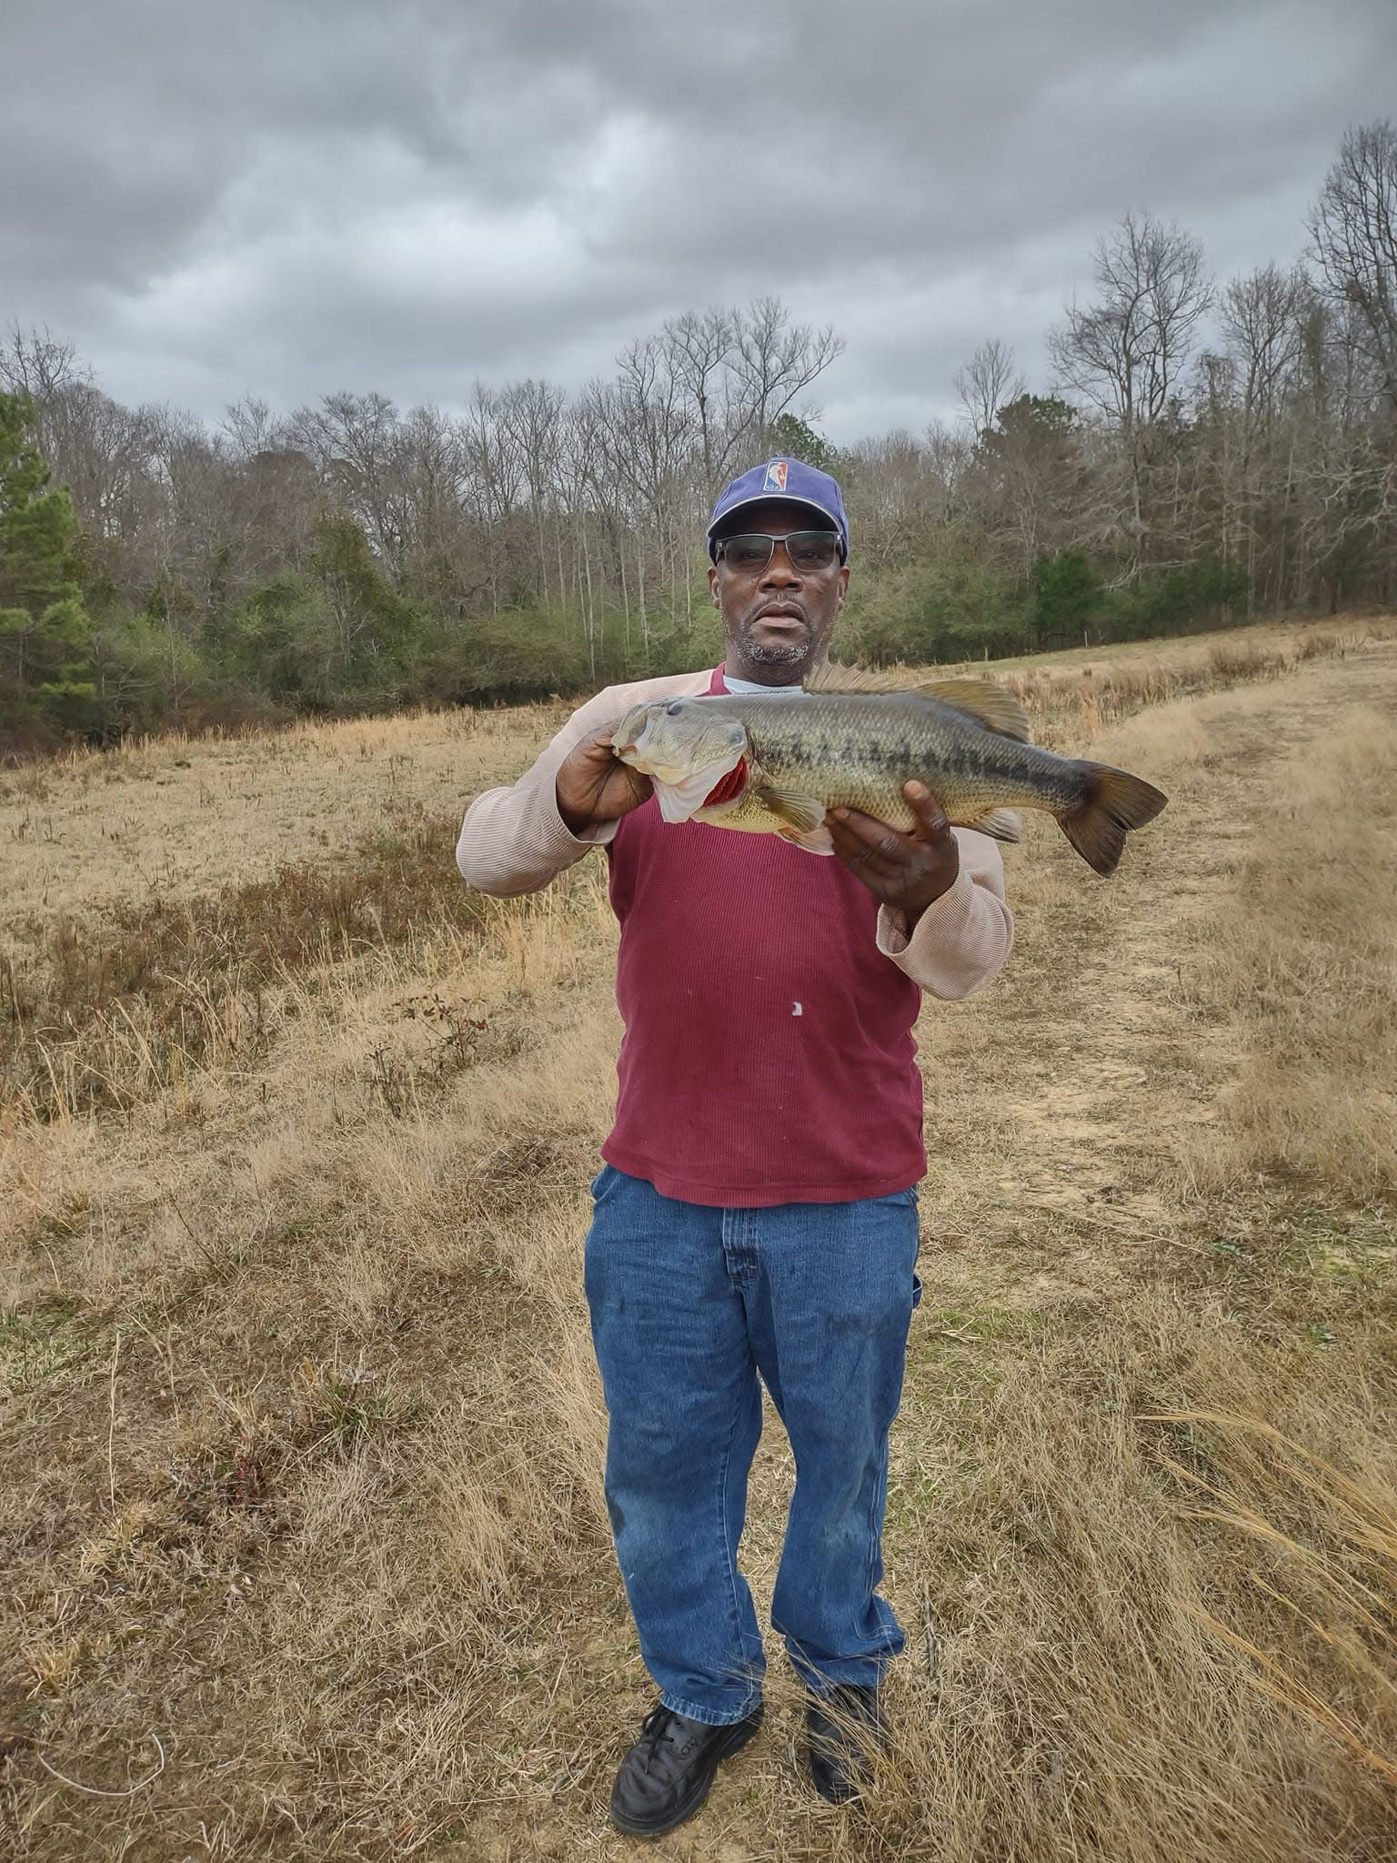
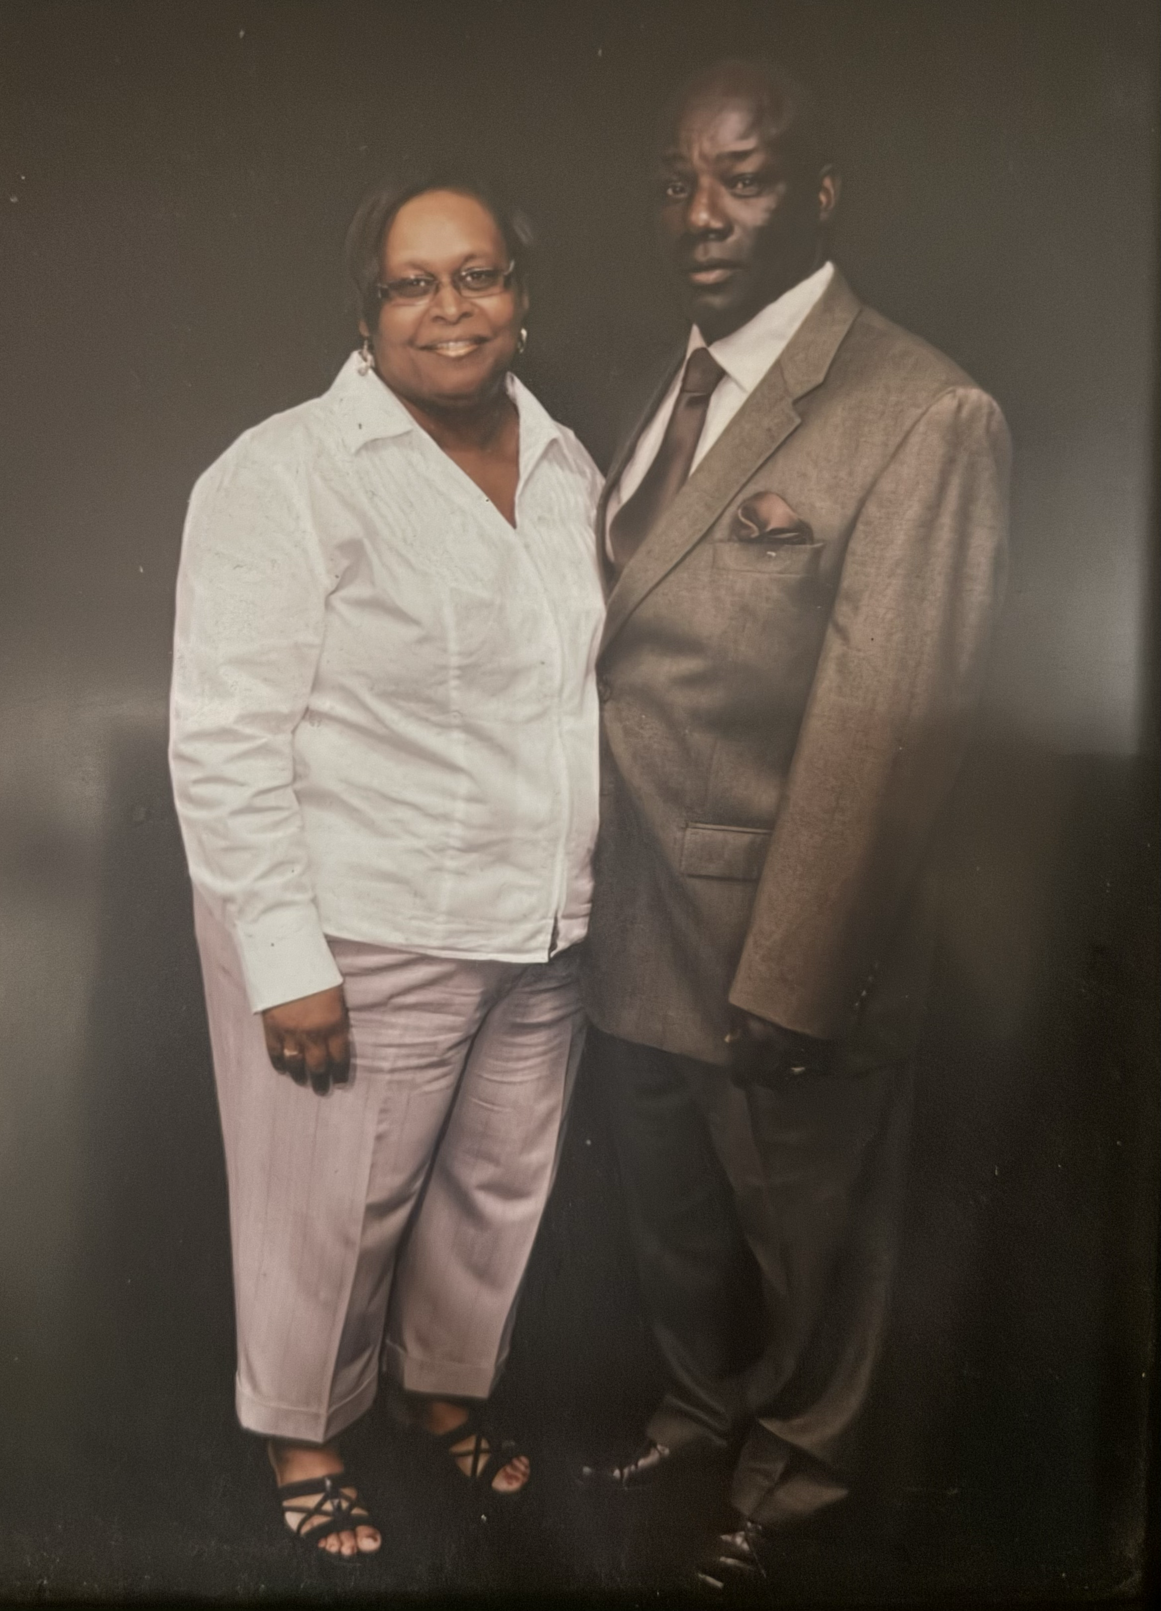
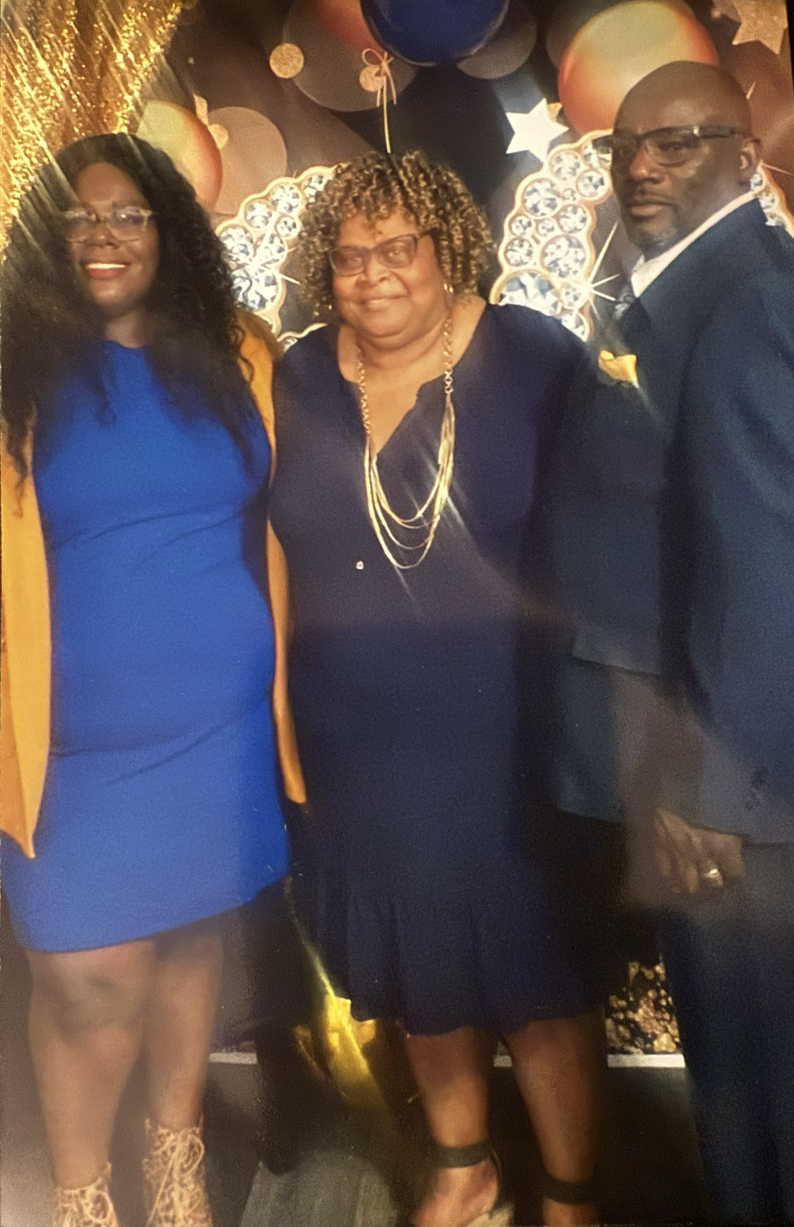
📝 Scholarship Application Form
George White Legacy of Building Scholarship Application
Presented by A-One Support & Mentorship
Applicant Information
- Full Name: ___________________________________________
- Date of Birth (MM/DD/YYYY): ___________________________
- Address: _____________________________________________
- City/State/Zip: _______________________________________
- Email: _______________________________________________
- Phone: _______________________________________________
- Parent/Guardian Name (if under 18): ____________________
- Parent/Guardian Phone: _______________________________

Academic Information
- Current School: _______________________________________
- Current Grade Level: __________________________________
- GPA (if applicable): __________________________________

Eligibility
- Applicants must be current high school senior on track to graduate in Spring 2026 and planning to enroll in a 2-year college, 4-year college, trade/technical school, or vocational program.
- Priority will be given to students pursuing careers in construction, architecture, engineering, business administration or skilled trades.

Application Requirements
- Completed application form
- One-page essay response (see essay prompt below)
- Two letters of recommendation from a teacher and community leader
- Most recent transcript with 3.0 GPA and proof of post-secondary education enrollment

Essay Prompt
"George White spent his life building—through his business, his Masonic brotherhood, and his dedication to family and community. In what ways do you hope to build opportunities, relationships, or positive change in your own life and community? How will this scholarship help you achieve those goals?"

Deadline for Submission: February 14, 2026
Award Amount: $500
Submit to: directors@topnotchmentality.com

Certification

I hereby certify that the information provided is true and complete to the best of my knowledge.

Applicant Signature: ___________________________ Date: ____________
Parent/Guardian Signature (if under 18): ____________________ Date: ____________

In Loving Memory of George Douglas White Jr. “Duck”
This scholarship stands as a tribute to George’s enduring legacy of faith, service, and craftsmanship. May every recipient be inspired to live with the same integrity, generosity, and determination that George shown throughout his life.
The A-One Support & Mentorship family is honored to continue his legacy by investing in the future of our youth.

